GI notes, Chapter 24

Two Major groups of organs involved
- GI (alimentary canal)
- Accessory organs (teeth, tongue, salivary glands, liver, gallbladder, and pancreas)
Functional segments of GI include the mouth, esophagus, small and large intestines

Ingestion- intake of food in the mouth
secretion- release of water, acid, buffers and enzymes
Mixing and propultion of luminal content
Digestion- mechanical and chemical (catabolism)
Absorption- transfer of digestion products from the GI to the blood and lymphatics for distribution to cells
Defecation- emptying of indigestible substances through the rectum

GI tact Functions
- Mouth- bite, chew and swallow
- Pharynx and esophagus- transport
- Stomach- mechanical disruption; absorption of water and alcohol
- Small intestine- chemical and mechanical digestion and absorption
- Large intestine- absorb electrolytes and vitamins (B and K)
- Rectum and anus- defecation
** In the SI and LI we absorb water because it can be a hard commodity to acquire. We reabsorb it to conserve it.
Layers of the GI tract
- Mucosal layer
  - Epithelium
    - stratified squamous (in mouth, esophagus and anus for durability)
    - simple columnar in the rest
      - secretes enzymes and absorbs nutrients
      - goblet cells secrete mucous onto cell surfaces
      - enteroendocrine cells secrete hormones controlling organ function
- Submucosal layer
  - Loose connective tissue contains blood vessels, glands and lymphatic tissue
  - Innervation- Meissner’s (submucosal) plexus
    - Parasympathetic and sympathetic innervation (autonomic nervous system)
    - Part of ENS (enteric nervous system)
      - Local movement by muscularis mucosae
      - Vasoconstriction of blood vessels
      - Innervates mucosal glands for secretions
- Muscularis layer- contains smooth and skeletal muscle
  - Skeletal muscle- voluntary control
    - Found in mouth, pharynx, upper esophagus and anus
    - Controls swallowing and defecation
  - Smooth muscle- involuntary control
    - Inner circular fibers and outer longitudinal fibers
      - Inner pinches off while longitudinal shortens tube, thus, movement (peristalsis) occurs
    - Mixes, crushes and propels food along via peristalsis
  - Auerbach’s (myenteric) plexus- controls GI motility (mainly global)
    - Both parasymphathetic and sympathetic innervation of circular and longitudinal smooth muscle layers
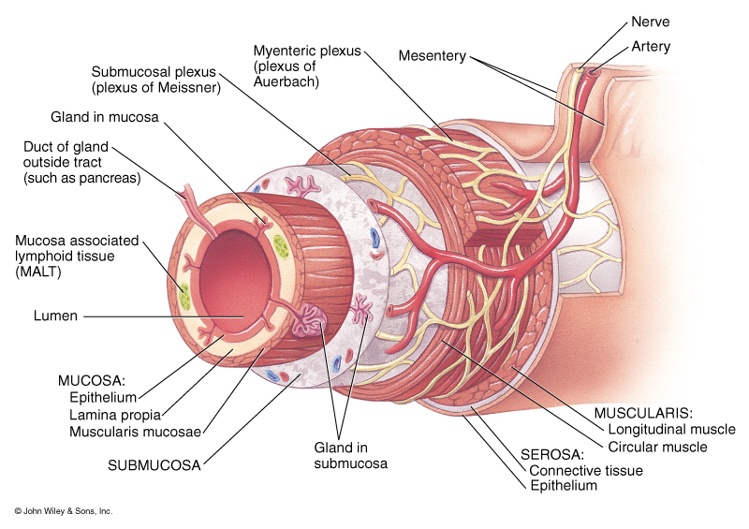
- Serosa layer- superficial layer that suspends organs in a body cavity
  - Covers all organs and walls of cavities not open to the outside of the body
  - Secretes slippery fluid
  - Consists of connective tissue covered with simple squamous epithelium
  - Esophagus is covered by adventitia; inferior to the diaphragm, the serosa is called peritoneum
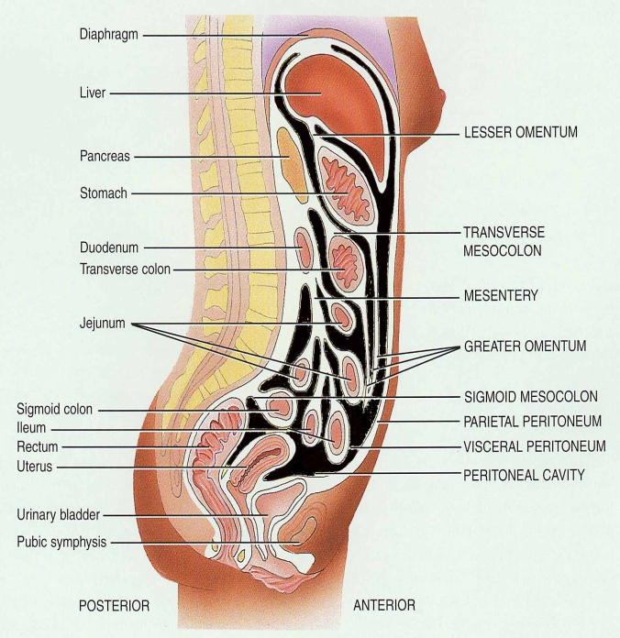
Peritoneum- largest serous membrane of the body
- Visceral layer covers organs
- Parietal layer lines the walls of the body cavity
- Large folds support organs in the viscera and contain blood and lymphatic vessels, and nerves
Peritoneal cavity
- Potential space containing a bit of serous fluid
Retroperitoneal
- Organs within the body wall (not suspended in the cavity)
  - Ie. pancreas and kidneys
Parts of the Peritoneum
- Mesentery- ligament like substance that suspends and holds small intestine
- Mesocolon- ligament like substance that suspends and holds colon in place
- Falciform ligament
- Lesser omentum- attaches the liver to the lesser curve of the stomach
- Greater omentum- attaches from the greater curve of the stomach, descends, folds then attaches to the transverse colon.
- Peritonitis- inflammation
  - Caused by trauma, rupture of GI tract, appendicitis, perforated ulcer and infection
Innervation of the GI tract
- Enteric Nervous System (ENS)
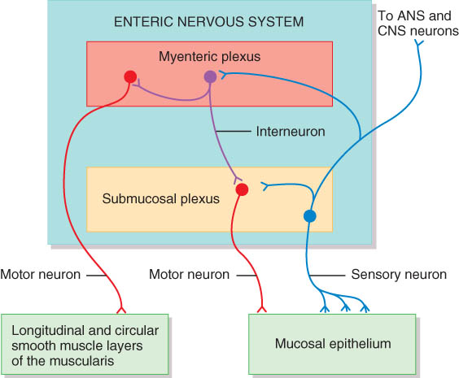
  - ENS consists of neurons that extend from the esophagus to the gut
  - Located in the myenteric (Auerbach’s) plexus and submucosal (Meissner’s) plexus
  - Consists of motor neurons, interneurons, and sensory neurons
  - Myenteric neurons control gastric motility
  - Submucosal neurons control the secretory cells (and local movements)
  - Can function independently of the CNS
Autonomic Nervous System (ANS)
- Vagus nerve (CN X) supplies parasympathetic fibers. They synapse with neurons in ENS and increase their action. Vagus passes through cranium, thorax and diaphragm.
- Sympathetic nerves arise from the thoracic and upper lumber regions of the spinal cord. They synapse with the ENS neurons and inhibit the ENS neurons.
**Parasympathetics stimulate GI where sympathetic inhibit GI
- Gastrointestinal Reflex Pathways
  - Regulate secretions and motility in response to stimuli present in the lumen
  - Reflexes begin with receptors associated with sensory neurons of the ENS
Mouth
- Lips and cheeks contain buccinators muscle. It helps keep food between upper and lower teeth
- Vestibule- area between cheeks and teeth
- Oral cavity proper
  - Roof- hard palate, soft palate and uvula
  - Floor- tongue
Salivary Glands
- Parotid- found below your ear and over masseter muscle. Empties via parotid duct in the maxilla (salivates upper mouth)
- Submandibular- found under lower edge of mandible. Drains into the floor of the mouth
- Sublingual- deep to the tongue in the floor of the mouth on either side of lingual frenulum
Gland Cellular Structure
- Cells found in clusters (acini)
- Serous cells secrete a watery fluid
- Mucous cells (pale staining) secrete a slimy, mucus secretion
- Salivary glands are all exocrine glands
Functions and Composition of Saliva
- Wet food for swallowing
- Dissolves food for tasting
- HCO₃⁻ ions buffer acidic foods
  - Bulemia- vomiting damages the enamel on teeth
- Chemical digestion of starch (carbohydrates) begins with the enzyme salivary amylase (released by the parotid glands)
- Enzyme lysozyme helps destroy bacteria. Used as a defense mechanism
- Protects mouth from infection with its rinsing action. We use 1-1.5 quarts per day
Formation of saliva
- Composed of H₂O, electrolytes, salivary amylase, lingual lipase and mucus
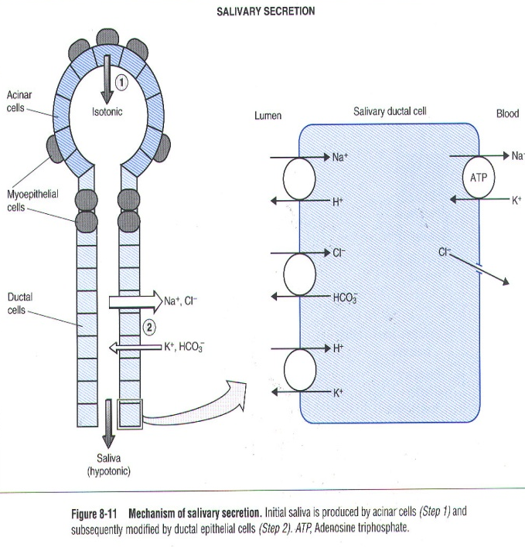
- Hypotonic relative to blood plasma
  - has a higher concentration of K⁺ and HCO₃⁻
  - has a lower concentration of Na⁺ and Cl⁻
- Formed in two steps
  - Acinar cells secrete isotonic saliva similar to blood plasma
  - Ductal cells modify saliva by:
    - Transporters found on the apical side (side of cell against the lumen) exchange the following Na⁺/H⁺, Cl⁻/HCO₃⁻ and H⁺/K⁺
    - Basolateral side has Na⁺/K⁺ ATPase and Cl⁻ channels
**The net effect is absorption of Na⁺ and Cl⁻ from the lumen and transferred to the blood, thus reducing the content in the saliva (hypotonic)
- Secretion of K⁺ and HCO₃⁻ increases their concentration in saliva. This is done at a slower rate than the Na⁺ and Cl⁻ are absorbed (again this makes the saliva hypotonic)
Salivation
- Entirely under nervous control (regulation)
- Increased salivation
  - Sight, smell, sounds, memory of food, tongue stimulation
  - Cerebral cortex signals the salivatory nuclei in brainstem
  - Parasympathetic innervations via facial and glossopharyngeal (CN VII & IX)
- Stop salivation- ie dry mouth when afraid
  - Sympathetic innervation
    - Psychological influences and irritant foods
Mumps- caused by Myxovirus which attacks the parotid gland
- Symptoms
  - Inflammation and enlargement of parotid, fever malaise and sore throat (especially swallowing sour foods), swelling on sides of face. Acidic foods tend to increase the pain associated with mumps.
  - In 30% of males there is testicular involvement, sterility is rare because often only one testicle is involved
  - Vaccine became available in 1967
Tongue
- Muscle of tongue is attached to hyoid, mandible, hard palate and styloid process
- Papillae are bumps and contain taste buds
  - Taste buds are protected by being on the sides of papillae
    - Vallate papilla- found on the back of the tongue, have about 100 taste buds
    - Foliate papilla- help move food to back of mouth
    - Fungiform papilla- found throughout tongue and contain about 5 taste buds
Tooth Structure and Composition
- Enamel- hardest substance in body. Made of calcium phosphate or carbonate
- Dentin- calcified connective tissue
- Cementum- bone-like. Periodontal ligament attaches to it
- Flossing alone lengthens tooth life expectancy by 3-5 yrs. This is due to a decrease of bacterial infections to the blood vessel epithelium.
Digestion in the Mouth- chewing more increases surface are for digestion purposes.
- Mechanical- digestion (mastication or chewing)
  - Breaks into pieces
  - Mixes with saliva to form bolus
- Chemical digestion
  - Salivary amylase (ptyalin)
    - Begins starch digestion at a pH of 6.5 or 7.0, found in mouth
    - When bolus and enzyme hit acidic (pH 2.5) gastric juices, the amylase is inactivated and hydrolysis ceases.
  - Lingual lipase
    - Secreted by glands in tongue (not the sublingual or parotid glands)
    - Activated by the acidity in the stomach
    - Breaks down triglycerides into fatty acids and monoglycerides
Pharynx- tube extending from internal nares to esophagus (posteriorly) and larynx (anteriorly)
- Skeletal muscle lined by mucous membrane
- Deglutition or swallowing is facilitated by saliva and mucus
  - Starts when bolus is pushed into oropharynx
  - Has voluntary and involuntary phase
  - Sensory nerves send signals to deglutition center in medulla oblongata
  - Soft palate is lifted to close nasopharynx
  - Larynx is lifted as epiglottis is bent to cover glottis
- Voluntary phase- tongue pushes food to back of oral cavity
- Involuntary phase- pharyngeal stage
  - Breathing stops and airways are closed
  - Soft palate and uvula are lifted to close off nasopharynx
  - Vocal cords are closed
  - Epiglottis is bent over airway as larynx is lifted
Esophagus
- Collapsible muscular tube found directly in front of vertebrae
- Pierces the diaphragm at the hiatus
  - At times parts will protrude back through hiatus causing a hiatal hernia or diaphragmatic hernia
Histology of the Esophagus
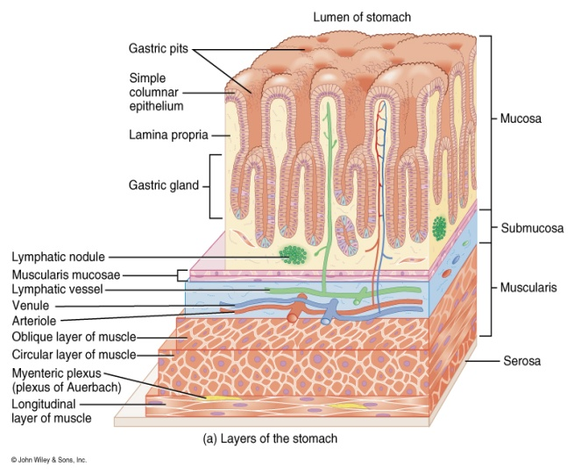
- Mucosa- stratified squamous
- Submucosa- large mucous glands
- Muscularis (various layers of muscle)
  - Upper 1/3 is skeletal
  - Middle is mixed
  - Lower 1/3 is smooth
  - Upper and lower esophageal sphincters are prominent circular muscles
- Adventitia- connective tissue blending with surrounding connective tissue (no peritoneum)

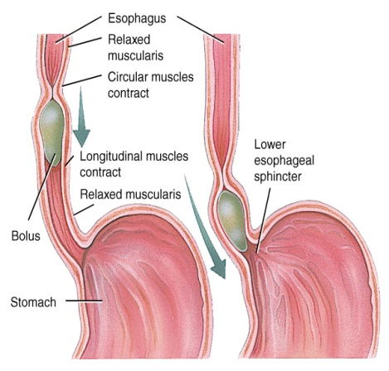
Swallowing
- Upper esophageal sphincter relaxes when larynx is lifted
- Stress relaxation
- Peristalsis pushes food down
  - Circular fibers behind bolus
  - Longitudinal fibers in front of bolus shorten the distance of travel
  - Travel time is 4-8 seconds for solids and 1 sec for liquids
  - Lower sphincter relaxes as food approaches
Gastroesophageal Reflex Disease
- If lower sphincter fails to open
  - Distension of esophagus feels like chest pain or heart attack
- If lower esophageal sphincter fails to close
  - Stomach acids enter esophagus and cause heartburn (GERD)
  - If having a weak sphincter- don’t eat a large meal and lay down in front of TV
  - Smoking and alcohol make the sphincter relax worsening the situation
- Control the symptoms by avoiding
  - Coffee, chocolate, tomatoes, fatty foods, onions and mint= foods that stimulate stomach acid secretions
  - Medications that
    - Reduce acid secretion- take 60 minutes before eating
    - Neutralize existing stomach acids- taking after meal

Anatomy of Stomach
- Stomach stretches due to rugae
- Parts of the stomach
  - Cardia
  - Fundus- On an X-ray the trapped air in fundus used as identification for the top of the stomach
  - Body
  - Antrum
  - Pylorus- starts to narrow toward pyloric sphincter
- Empties as small squirts of chime leave the stomach through the pyloric sphincter
Pylorospasm and Pyloric Stenosis
- Abnormalities of the pyloric sphincter in infants
- Pylorospasm
  - Muscle fibers of sphincter fail to relax trapping food in the stomach
  - Vomiting occurs to relieve pressure
- Pyloric stenosis
  - Narrowing of sphincter indicated by projectile vomiting
  - Must be corrected surgically
Mucosa and Gastric Glands (mucus prevents acid from degrading epithelium)
- Parietal (oxyntic) cells secrete
  - HCl- activates enzymes and starts proteolysis
  - Intrinsic factor- needed for absorption of vitamin B₁₂ in small intestine (B₁₂ needed for RBC production). Intrinsic factor is secreted within stomach.
  - Ghrelin- hormone released when the stomach is empty; produces the sensation of hunger. Stimulates hypothalamus to secrete GHRH which primes the body to take advantage of any food that may be ingested, secretion of ghrelin decreases within an hour of eating.
  - Chief cells (zymogenic cells) secrete
    - Pepsinogen- converted to pepsin by HCl. Pepsin breaks down proteins
    - Gastric lipase- digests lipids
*** when we see –gen it is a precursor
  - G (enteroendocrine) cells secrete gastrin hormone = ‘get it out of here’
    - Release more gastric juice
    - Increase gastric motility
    - Relax pyloric sphincter
    - Constrict (lower) esophageal sphincter preventing reflux
    - G cells are mostly found in the antrum
  - D cells secrete somatostatin which inhibits growth
  - Histamine releasing cells (enterochromaffin like cells)
    - Parietal cell secretion is stimulated by Histamine, Ach, and gastrin
    - H₂ antagonists (block histamine receptors- used as antacid [cimetidine])
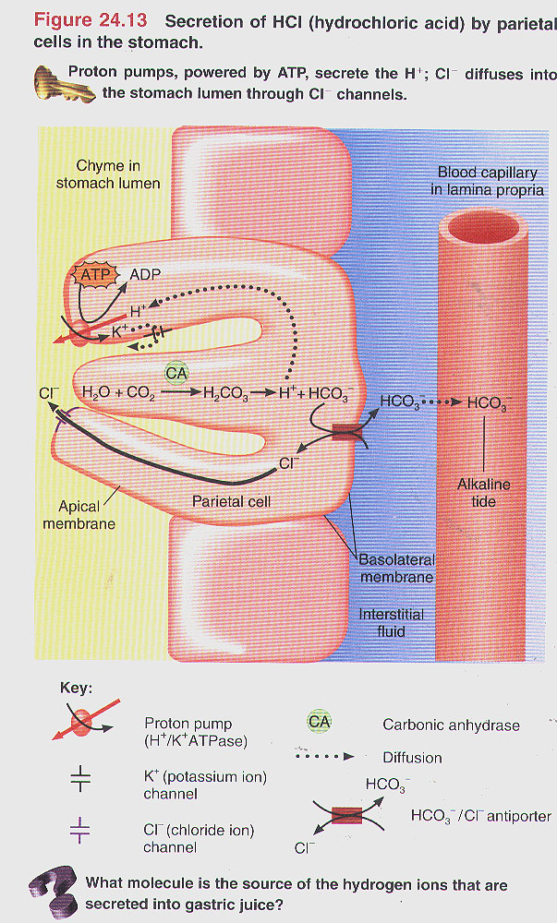
Parietal (oxyntic) cells
- Alkaline tide- an increase in pH in the gastric blood capillaries. H⁺ is pumped into the gastric lumen via primary active transport
- HCO₃⁻ is pumped into the blood capillary from the parietal cell in exchange for Cl⁻
Submucosa- composed of areolar tissue
Muscularis- 3 layers of smooth muscle (instead of 2)
- Outer longitudinal
- Circular
- Inner oblique
- These permit greater churning and mixing of food with gastric juice
Serosa- part of the visceral peritoneum
- Simple squamous epithelium over a bit of connective tissue
- Also known as visceral peritoneum
- At the lesser curvature, the serosa becomes the lesser omentum; at the greater curvature it becomes the greater omentum
Mechanical Digestion
- Churning- gentle mixing waves every 15 to 25 seconds
  - Mixes bolus with 2 quarts per day of gastric juice to turn it into chime (a soupy liquid)
  - Retropulsion- more vigorous waves
    - Travel from body of stomach to pyloric region
  - Peristalsis- intense waves near the pylorus
    - Open it and squirt out 1-2 teaspoons full with each wave
Chemical Digestion
- Protein digestion begins
  - HCl denatures (unfolds) protein molecules
  - HCl transorms pesingoen into pepsin that breaks peptide bonds between certain amino acids. Pepsin is most active at a pH of 2.
- Fat digestion begins
  - Gastric lipase splits short chain triglycerides to fatty acids and monoglycerides (abundant in milk fat and butter)
  - Most effective at pH 5 to6 (infant stomach), has a limited role in adults because the adult pH is about 2.
- HCl kills microbes in food and breaks down proteins
- Mucous cells protect stomach walls from being digested with 1-3mm thick layer of mucous.
Absorption of Nutrients by the stomach
- Water
- Electrolytes
- Some drugs- aspirin (acelacilic acid) and Alcohol
  - Fat content in the stomach slows down the absorption of alcohol.
  - Gastric mucosal cells contain alcohol dehydrogenase which converts alcohol to acetaldehyde. There is more of this enzyme in men than in women.
  - Females have less total body fluid than males. Thus they end with higher blood alcohol levels with the same amount of intake
Vomiting (emesis)- expulsion of contents of stomach and duodenum through mouth
- Caused by
  - Irritation or distension (stretching) of stomach
  - Unpleasant sights, general anesthesia, dizziness and certain drugs
- Sensory input from medulla cause stomach contraction and complete sphincter relaxation
- Can be serious because of loss of acidic gastric juice can lead to metabolic alkalosis
Regulation of Gastric Secretion and Motility
- Regulated by nervous and hormonal control
- Has 3 overlapping phases:
  - Cephalic phase: Stomach Getting Ready
    - Only under neuronal control
    - Cerebral cortex- sensory input from sight, smell, taste and thoughts
      - Stimulate parasympathetic nervous system
    - Vagus nerve (CN X)
      - Increases stomach muscle and glandular activity. Postganglionic neurons in submucosal plexus (Meissner’s plexus) stimulates gastric glands to secrete HCl, pepsinogen and mucus into stomach and gastrin into blood.
    - Sympathetic activity due to anger, fear, anxiety inhibits gastric activity
  - Gastric phase= ‘Stomach Working”
    - Contains both, neuronal and endocrine (hormonal) control
    - Nervous keeps stomach active
      - Stretch receptors and chemoreceptors provide information
      - Vigorous peristalsis and glandular secretions continue
      - Chime is released into the duodenum
    - Endocrine
      - Distention, presence of protein or caffeine, increased pH cause G cells secretion of gastrin into bloodstream
      - Gastrin hormone
        - Lower esophageal sphincter to contract
        - Increases stomach glandular secretion
        - Increases stomach churning
        - Pyloric sphincter relaxation

  - Intestinal phase= “Stomach Emptying”
    - Enterogastic Reflex- regulates amount released into the intestines
      - Neuronal influences
        - Mechanoreceptors- duodenal distension activates stretch receptors which slows stomach but increases intestinal activity.
          - Parasympathetic nerves increase intestinal activity where sympathetic decrease stomach activity
        - Chemoreceptors- digestion products, fatty acids, peptides and sugars signal the medulla
        - Hormonal influences
          - Secretin hormone decreases stomach secretions (released by SI)
          - Cholecystokinin (CCK) decreases stomach motility and emptying (tells it to relax)
          - Gastric inhibitory peptide (GIP) decreases stomach secretions, motility and emptying
      - Sensory impulses sent to the medulla inhibit parasympathetic stimulation of stomach but stimulate sympathetic impulses. Increases CCK secretion
      - Inhibition of gastric emptying
Pancreas
- Head close to duodenum
- Main duct joins common bile duct from liver
- Acini- dark clusters found on a histology slide
  - 99% of gland, produces pancreatic juice
- Islets of Langerhans- pale staining cells on slide
  - 1% of gland, produces hormones
Pancreatic Juice
- 1.5 quarts excreted per day at pH of 7.1-8.2
- Contains water, enzymes and sodium bicarbonate
- Digestive enzymes
  - Pancreatic amylase (digest carbs)
  - Pancreatic lipase (digest lipids)
  - Proteases (digest proteins)
    - Trypsinogen- activated by enterokinase (a brushborder enzyme), when activated to Trypsin, will activate many other proteases.
    - Chymotrypsinogen- activated by trypsin
    - Procarboxypeptidase- activated by trypsin. Brush border enzyme that clips off carboxyl groups from the protein
    - Proelastase- activated by trypsin
    - Trypsin inhibitor- combines with any trypsin produced inside pancreas
  - Ribo- and deoxyribonucleases- digest nucleic acids to oligonucleotides and single nucleotides
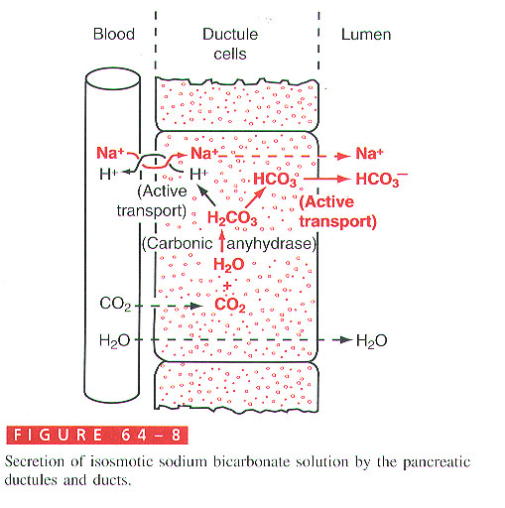
- In the picture to the right note the acidification of pancreatic venous blood; Compare this with the alkalinization of the stomach venous blood
Pancreatitis
- Inflammation of the pancreas occurring with the mumps
- Acute pancreatitis- associated with heavy alcohol intake or biliary tract obstruction
  - Patient secretes trypsin in the pancreas and starts to digest himself
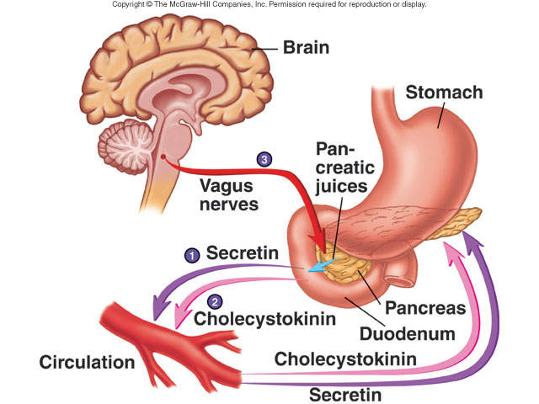
Regulation of Pancreatic Secretions
- Secretin- acidity in intestine causes increased sodium bicarbonate release
- GIP- fatty acids and sugar cause increased insulin release
- CCK- fats and proteins cause increased digestive enzyme release
Anatomy of the Liver and Gallbladder
- Liver (king of metabolism)
  - Gallbladder found under right lobe
Histology of the Liver
- Hepatocytes arranged in lobules
- Sinusoids in between hepatocytes are blood-filled spaces
- Kupffer cells- phagocytize microbes and foreign matter
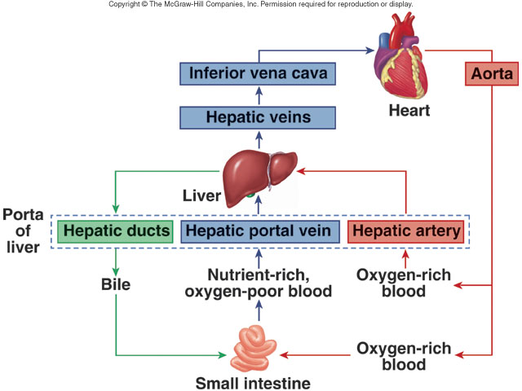
- Contains sinusoidal capillaries
Blood Supply to the Liver
- Hepatic portal vein
  - Nutrient rich blood from stomach, spleen and intestines
  - Hepatic artery is from a branch off the aorta (celiac trunk)
  - Portal vessels- blood vessels contained between 2 capillaries beds. Example is the hepatic portal vein
Gallbladder
- Simple columnar epithelium
- No submucosa
- 3 layers of smooth muscle

Bile Secretion
- Bile capillaries
- Left and Right hepatic ducts connect to form common hepatic duct
- Cystic duct from gallbladder and common hepatic form to common bile duct
- Common bile and pancreatic ducts empty into duodenum
Bile Production
- 1 quart is secreted by liver per day
  - Yellow-green in color and pH 7.6 to 8.6 (due to HCO₃⁻)
- Components
  - Water, bicarbonate and cholesterol (synthesized by liver)
  - Lecithin (phospholipid)
  - Bile salts and lecithin emulsify lipids- form micelles to increase surface area
  - There is only 50% fat absorption w/o bile and 97% absorption of fats in micelles with bile
  - Globin- a reusable protein
  - Heme- iron and bilirubin
  - Jaundice- yellow coloration of sclera, skin and mucus membranes
    - Prehepatic- excess production of bilirbuin
    - Hepatic jaundice- congenital liver disease, cirrhosis, hepatitis
    - Extrahepatic- due to blockage of bile ducts (gallstones etc)
    - Neonatal
Regulation of Bile Secretion
- Parasympathetic impulses (Vagus) stimulate bile production by liver
- Fatty acids and amino acids in chyme entering duodenum stimulate secretion of CCK into blood. Acidic chyme entering duodenum stimulates secretion of secretin into blood
- CCK causes contraction of gallbladder
- Secretin enhances flow of bile rich in HCO₃⁻ from liver
Reabsorption of bile salts takes place in the distal ileum
Eating fruits and vegetables decreases the amount of bile reabsorbed, causing the liver to have to make more thus decreasing cholesterol concentrations in the blood
Liver functions
- Carbohydrate metabolism
  - Gluconeogenesis- turns proteins and triglyceriedes into glucose
  - Glycogenesis- turn excess glucose into glycogen and store in the liver
  - Glycogenolysis- turn glycogen back into glucose as needed
- Lipid metabolism
  - Synthesize cholesterol
  - Synthesize lipoproteins- HDL and LDL (transport fatty acid etc)
  - Stores some fat
  - Breaks down some fatty acids
- Protein metabolism
  - Deamination- removes NH₂ from amino acids
  - Converts resulting toxic ammonia (NH₃) into urea for excretion by kidneys
  - Synthesizes plasma proteins for clotting mechanism (prothrombin, fibrinogen), most plasma proteins (albumin) and immune system (globulins)
  - Convert one amino acid into another
- Detoxifies blood by removing drugs and hormones (thyroid and estrogen). Liver and kidneys most often affected by drugs due to filtration mechanism
- Removes waste product- bilirubin
- Releases bile salts- help digestion by emulsification
- Stores fat soluble vitamins- A,D,E,K
- Stores iron and copper
- Phayoocytizes worn out blood cells and bacteria
- Activates vitamin D
Small Intestine surface area
- Plicae circularis- 3x
- Villi- 30x
- Microvilli- 600x
Small Intestine
- Plica circularis- permanent ½ inch tall folds contain part of submucosal layer
  - Can’t stretch like Rugae
- Villi- core is lamina propria of mucosal layer
  - Contains vascular capillaries and lacteals (lymphatic capillaries which absorb fat)
- Microvilli- brush border
Microvilli
- Digestion and Absorption
- Enzymes found at cell surface
- Digestion occurs at cell surfaces
Cells of Intestinal Glands
- Absorptive cell
- Goblet cell- unicellular gland, simple columnar epithelium
- Enteroendocrine
  - Secretin- secreted by S cells
  - Cholecystokinin- secreted by CCK cells in duodenum and jejunum
  - Gastric Inhibitory Peptide (GIP)
  - Peptide YY (PYY)- secreted by ileum and colon
    - Signals satiety (stop eating)
    - Stimulated by food
    - Secretion is proportionate to calories consumed
    - Prevents stomach from emptying too fast which prolongs the sense of satiety
  - Paneth cells- secrete lysozyme (breaks down bacterial cell walls), phagocytosis
Intestinal Juice and Brush-Border Enzymes
- Submucosal layer has duodenal glands that secrete alkaline mucus
- Mucosal layer contains intestinal glands- Crypts of Lieberkuhn
  - 1-2 guarts per day at pH 7.6
  - Brush border enzymes break up smaller compounds into smaller ones
    - CHO digestion- alpha dextrinase, maltase, sucrase, and lactase (all are disaccharidases)
    - Proteins- peptidases (aminopeptidase and dipeptidase), enterokinase
    - Nucleic acid digesting enzymes- nucleosidases and phosphotases
    - No lipid enzymes (lipase) found in brush border enzymes
Small Intestine
- Greatest digestion and absorption of anything occurs in the small intestine
- Weak peristalsis compared to stomach
- Segmentation- local mixing of chyme with intestinal juices (sloshing back and forth)
- MMC (migrating motility complex)- between meals for emptying small intestine
Regulation of Secretion and Motility
- Reflexes that respond to presence of chyme
  - Hormonal- VIP (vasoactive intestinal polypeptide) stimulates the production of intestinal juice and increases intestinal motility
  - Neuronal- segmentation depends on distention which sends impulses to enteric plexus and CNS. Sympathetic impulses decrease motility
Hydrolysis- using water to break down large molecules into small molecules (catabolic reaction)
Digestion
- Carbohydrates
  - Mouth- salivary amylase
  - Esophagus and stomach- nothing
  - Duodenum- pancreatic amylase
  - Brush border enzymes- maltase, sucrase, lactase and alpha dextrinase
    - Produces monosaccharides (that is only form of carbs we can absorb)
    - Lactose intolerance- no lactase resulting in gas and diarrhea
- Proteins
  - Stomach- HCl denatures or unfolds proteins then pepsin turns proteins into peptides
  - Pancreas- digestive enzymes split peptide bonds b/w different amino acids (trypsin, chymotrypsin, carboxypeptidase, elastase)
  - Brush border enzymes complete digestion of short peptides
    - Aminopeptidase and dipeptidase- split off amino acid at amino end of molecule or split dipeptides. (we can absorb mono, di and tripeptides)
- Lipids
  - Mouth- lingual lipase (becomes activated in stomach)
  - Stomach- gastric lipase (think infants)
  - Pancreas- pancreatic lipase
  - Small intestine- pancreatic lipase splits long-chain triglycerides into fatty acids and monoglyceride
  - No lipases in brush border
- Nucleic acids
  - Ribonuclease (RNAse) digests RNA
  - DNAse digests DNA
  - Brush border enzymes (nucleosidases and phophatases) digest nucleotides to pentose, phosphate and nitrogenous bases
  - Absorbed by active transport
Absorption
- Monosaccharides
  - Glucose and galactose- Na⁺ symporter (secondary active transport). Na comes in with glucose and galactose. Facilitated diffusion on the basolateral side
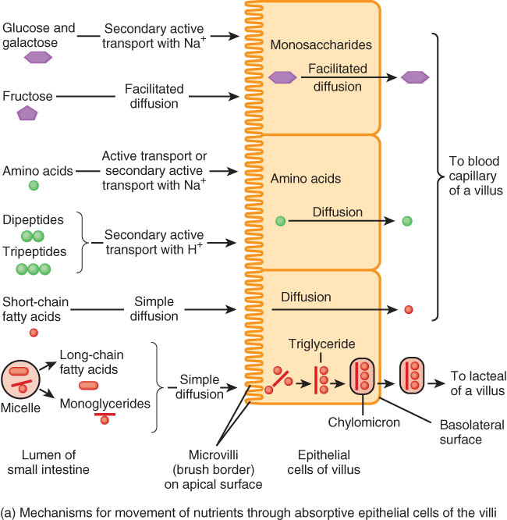
  - Fructose- facilitated diffusion on both sides (in and out)\
  - Movement out of cell into bloodstream is done through facilitated diffusion for glucose, galactose and fructose
- Amino acids and dipeptides
  - Active transport with Na⁺ or H⁺ ions (symporters)
  - Movement out of cell into blood is through diffusion
  - Di and tripeptide absorption is faster than single amino acids. Di and tripeptides are broken down to single aa inside cell for diffusion into capillaries
- Lipids
  - Small fatty acids enter cell and blood by simple diffusion
  - Large lipids exist only w/in micelles
  - Lipids enter cells by simple diffusion leaving bile salts in lumen
    - Bile salts reabsorbed into blood and then reused by liver
  - Fat-soluble vitamins (A, D, E, K) w/in micelles enter cells by diffusion
  - Inside cells, fats are rebuilt (via SER) and coated with amphipathic lipoproteins to form chylomicrons then released via exocytosis into a lacteal
  - They travel in lymphatics to veins near the heart.
  - They are removed from the blood by liver and fat tissue. Lipoprotein lipase in cells break down triglycerides into FA which diffuse into adipocytes or hepatocytes
Absorption of Electrolytes
- Na/K pumps (active transport)
- Chloride, iodide and nitrate- passive transport
- Iron, magnesium and phosphate ions- active transport
- Ca absorption requires vitamin D and parathyroid hormone (PTH)
Electrolyte transport in SI
- Jejunum- NaHCO₃
- Ileum- NaCl absorption, HCO₃⁻ secretion
Absorption of Vitamins
- Fat-soluble vitamins travel in micelles and are absorbed by simple diffusion
- Water-soluble vitamins (B and C) are absorbed by diffusion
- B₁₂ combines with intrinsic factor (secreted by parietal cells) before it is transported into the ileum via receptor mediated endocytosis
Absorption of water is by osmosis through cell walls into vascular capillaries inside villi
Large Intestine
- Internal sphincter- smooth muscle and involuntary
- External sphincter- skeletal muscle and voluntary control
Appendicitis
- Inflammation of appendix due to blockage of lumen by chyme, foreign body, carcinoma, stenosis or kinking
- Symptoms
  - High fever, high WBC count, neutrophil count above 75%
  - Referred pain, anorexia, nausea and vomiting
  - Pain localizes in right lower quadrant
  - Pain caused upon release of pressure
Large Intestine
- Mucosa
  - Smooth tube- no villi or plica
  - Simple columnar cells absorb water and goblet cells secrete mucus
- Submucosal and mucosa contain lymphatic nodules
Mechanical Digestion of LI
- Smooth muscle- mechanical digestion
- Haustral churning- relaxed pouches are filled from below by muscular contractions (elevator)
- Gastroilial reflex- when stomach is full, gastrin hormone relaxes ileocecal sphincter so small intestine will empty and make room
- Gastrocolic reflex- mass peristalsis- when stomach fills, a strong peristaltic wave moves contents of transverse colon into rectum. This means that it is time to GO!!!
Chemical Digestion in LI
- NO enzymes are secreted, only mucous
- Bacteria ferment
  - Undigested carbohydrates changed into carbon dioxide, hydrogen and methane gas (flatulence)
  - Undigested proteins into simpler substances (indoles)- odor
  - Turn bilirubin into simpler substances that produce color
  - We have more bacteria in our body than cells
- Bacteria produce vitamin K and several B vitamins
Absorption and Feces Formation in the LI
- Some electrolytes- Na⁺ and Cl⁻
- After 3-10 hours, 90% of H₂O has been removed from chyme
- Feces- dead epithelial cells, undigested food or inabsorbable food such as cellulose, bacteria (live and dead)
Defecation
- Parasympathetic nerves contract muscles of rectum and relax internal anal sphincter
- External sphincter is voluntarily controlled
Dietary Fiber
- Insoluble Fiber
  - Woody parts of plants (wheat bran, veggie skins)
  - Speeds up transit time and reduces colon cancer
Soluble fiber
- Gel-like consistency- beans, oats, apples, citrus white parts
- Lowers blood cholesterol by preventing reabsorption of bile salts so liver has to use cholesterol to make more

