Miscellaneous Pathology Factoids
Rudolph Virchow is the Father of Pathology.
Pathos = study of suffering.
Physician = person skilled in the art of healing.
Healing = resolution of suffering.
Extravasate = to force out of the proper vessels; (blood) especially the diffusion into surrounding tissues.

Anatomical Pathology – evaluation of surgically removed parts
Clinical Pathology – laboratory testing and procedural analyses
Forensic Pathology – prediction and assessment of cause of death
Experimental Pathology – invention of study/research strategies for new pathological findings
Etiology – the study of causation and origination of disease; most are idiopathic
Idiopathic – unknown cause
Iatrogenic – caused by the diagnosis, manner, or treatment of a physician
Pathogenesis – the process by which disease is manifested; production and development of disease
Differential Diagnosis – the list of possible etiologies for a given condition

Pernicious anemia is a megaloblastic anemia where lymphocytic and plasma cell activity is increased drastically. Antibody formation targets parietal and chief cells in the stomach, killing them. If no parietal cells are present, no intrinsic factor (glycoprotein) will be made. Thus, cobalamin (vitamin B₁₂) cannot be absorbed in the ileum of the small intestine. Ultimately, a lack of cobalamin is the etiology of pernicious anemia. Those who have pernicious anemia have a 30% greater chance of developing gastric cancer.
Ablation of pituitary decreased Adrenocorticotropic hormone (ACTH) decreased cortisol output due to adrenal gland atrophy hypocortisol

The induction of adaptation or either injury status from stresses is dependent on the cellular metabolic status, blood supply, and nutritional status. Basically, if person A is active and healthy, then this person can afford to “slip” up on consumption of toxins (alcohol) occasionally. However, if person B, who is not active and overweight, tries to mimic person A, then person B is more likely to succumb to greater amounts of cellular injury than person A.

Grave’s Disease: thyroid hyperplasia (pathologic, “trophic”), hypermetabolism, exothalmus (forward displacement of the eyes)
Hypothyroidism: also known as goiter. This occurs because of an iodine deficiency. Iodine is needed for production of thyroid hormone. If thyroid-stimulating hormone’s release is not inhibited by the production of thyroid hormone, then thyroid-stimulating hormone will accumulate in the thyroid gland itself. A goiter is formed.
Lung congestion or bronchiectasis is the inability of cilia to project material out of the lungs due to cellular and cytoskeletal aberrations and abnormalities.
Leukocytes function as scavengers; they are the removers of debris and the killers of microbes. Leukocytes contain a multitude of enzymes which are housed in their lysosomes. Lysosomal enzymes are synthesized in the RER, and then sent for packaging in the golgi apparatus. Once the golgi has packaged the RER product, the product is a primary lysosome. If primary lysosomes fuse with other vesicles (phagosomes), they then are considered secondary lysosomes or phagolysosomes. If material that has been brought in from the extracellular matrix is phagocytosed and fused with a lysosome, then the process is termed, heterophagy. On the other hand, if intracellular material is fused with a lysosome, like products of free ribosomes, the process is termed, autophagy. Autophagy normally occurs to rid the cell of any unneeded organelles and for normal cellular modification. At times, some material that is brought in to the lysosome cannot be fully degraded. Thus, the result is a residual body. Genetic defects can alter many enzymes that are manufactured for lysosomal enzymatic activity. Such alterations of enzymes can result in lysosomal storage diseases. There are 400-500 known storage disorders and these disorders are very common in nervous tissue.

Cellular viability = functioning cell membrane. If eosin is added to cells and there is no change in color in the cells, then the cells are considered viable. When cellular viability has started to fade, eosinophilia will be observed because there is a loss of cytoplasmic RNA. (Remember nuclear material stains purple–hematoxylin, and proteins stain pink—eosin.)
Cell stress genes are expressed when cells are in hostile or unfavorable conditions. These genes produce cell stress proteins. One major cell stress protein is ubiquitin. Ubiquitin removes damaged proteins by acting as a cofactor of proteolysis. Ubiquitin-damaged proteins are then recognized by proteases. Also, ubiquitin is a heat shock protein, which will be expressed when under heat stress and other cellular stress. Thus, degradation of cytoskeletal and other vital proteins will ensue. Contrarily, structural genes are usually turned off when cells are subjected to stress.
Caffeine Mechanism
Caffeine ingestion phosphodiesterase is blocked increased amounts of cAMP more phosphodiesterase production caffeine still overpowers phosphodiesterase after caffeine is lessened the high concentration of phosphodiesterase will deactivate cAMP decreased energy and withdrawal effects
Neo-antigens are the leftover proteins, the byproducts of viral synthesis which are inserted into the cell membrane. These antigens then play a role in cell-mediated immunity. T-lymphocytes attack the neo-antigen on the hepatocyte or another cell type, which in turn kills the cells by necrosis. This death takes on a “ballooning” degradation appearance in hepatitis cases, and shows eosinophilia. This viral process is undoubtedly an indirect cytopathic effect.

Liquid nitrogen is applied to liver tissue to preserve fatty tissue for histological specimen preparation.

Tissue that participates in elimination pathways (kidneys and liver) usually are injured in the process. Nephro-, hepato-, and marrowtoxins are substance eliminated.
Chloramphenicol is a marrowtoxic antibiotic. Acetaminophen and hepatotoxic CCl₄ are both indirect cytotoxins. Alcohol is also an indirect cytotoxin, due to the formation of aldehydes when alcohol is broken down. Acetaminophen is broken down to yield superoxide molecules (O₂.); CCl₄ CCl₃. Both free radicals that are formed during normal metabolism of these substances jumpstart lipid peroxidation.

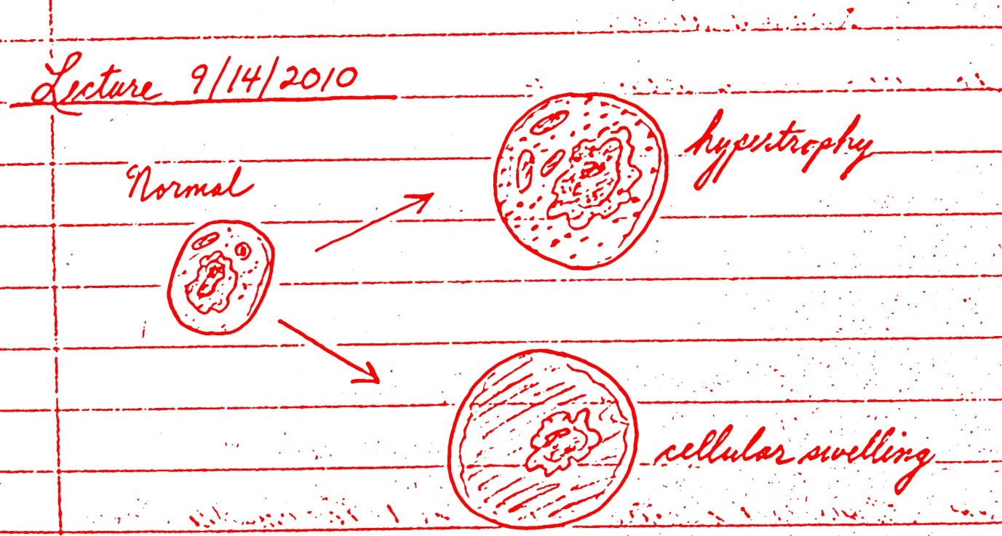
Pathologic Calcification = abnormal deposits of calcium salts, along with iron, magnesium and other minerals. Dystrophic calcification occurs in dead or dying cells; therefore, it occurs in the absence of calcium metabolic derangements. Hyperkalemia can exacerbate this condition. Metastatic calcification occurs in normal living tissues; therefore, derangement in calcium metabolism is evident: hyperkalemia. Causes of hyperkalemia: increased parathyroid hormone due to tumors or production of parathyroid hormone-related protein by other malignant tumors; destruction of bone due to effects of accelerated osteoclastic activity (Paget syndrome); vitamin D related disorders; and renal failure causing phosphate retention which leads to secondary hyperthyroidism.

Subcellular Responses to Injury
Autophagy
Induction (hypertrophy) of SER
Mitochondrial Alterations: with cellular hypertrophy, there is mitochondrial hyperplasia; with cellular atrophy, there is mitochondrial involution.

Cytoskeletal Significance
*intracellular transport of organelles and molecules
*maintenance of basic cell architecture (cell polarity; distinguish from up and down)
*transmission of cell to cell and cell to extracellular signals to the nucleus
*maintenance of mechanical strength for tissue integrity
*cell mobility and phagocytosis
Microtubules are important for leukocyte migration and phagocytosis. If there is decreased phagocytic ability, most likely there is microtubule polymerization (Gout). Colchicine prevents microtubule polymerization.
Important Targets of Injurious Stimuli
Mitochondria: site of ATP production
Cell membrane: ionic and osmotic homeostasis dependent organelles; and the cell
Protein synthesis: need for structures, enzymes, etc.
Genetic apparatus of the cell

